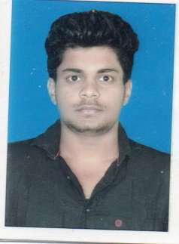**RESUME**

NITIN KUMAR JHA

Godbhaga, Sambalpur Odisha, 768111

Cont. - 7978056492

Email- [nitinjha775@gmail.com](mailto:nitinjha775@gmail.com)

CAREER OBJECTIVE

Work for an organization which provides me the opportunity to improve my skills and knowledge to growth along with the organization objective.

EDUCATION QUALIFICATION

|  |  |  |  |  |
| --- | --- | --- | --- | --- |
| **Qualification** | **University/College** | **Board/Affiliation** | **Percent (%)** | **Year of passing** |
| MBA-FM | Gangadhar Meher University | UGC | 79% | 2021 |
| B.COM | Vikash Degree College | CBCS | 6.79 CGPA | 2019 |
| Higher Secondary(+2) | Attabira college | CHSE | 58% | 2016 |
| Secondary School (10th) | Siddhartha Public School | CBSE | 8.4 CGPA | 2014 |

SOFT SKILLS

* Leadership
* Teamwork
* Responsible

EXTRA CURRICULAR ACTIVITIES

* Participated in National seminar on “Corporate social responsibility : policies and practices”
* Organized free food and medicine for poor during pandemic.
* Participated in role play on “Say no to tobacco” at school level.

PERSONAL INFORMATION

Date of Birth : 18 May 1999

Marital Status : Unmarried

Gender : Male

Language known : Hindi, English and Odia

Hobbies : Bike riding, Exploring new places

DECELARATION

I do hereby declare that all the information given above is true to the best of my knowledge.

Date :

Place : Sambalpur NITIN KUMAR JHA